1. INTRODUCTION
1.1. Project Overview
Flavour Fusion is an AI-driven recipe blogging web application designed to generate customized and well-structured recipe blogs based on user input. The application allows users to enter a recipe topic and specify the desired word count. Using a pre-trained generative AI model, the system produces detailed and engaging recipe content in a short time.
The project aims to simplify the process of recipe content creation for food bloggers, cooking enthusiasts, and busy individuals. Instead of manually writing lengthy recipes, users can rely on the application to generate high-quality content instantly. The application is built using Streamlit for the user interface and integrates the Gemini Flash Lite (models/gemini-flash-lite-latest) model for efficient and fast text generation.
Overall, Flavour Fusion demonstrates the practical use of generative AI in content creation by providing a user-friendly, time-saving, and effective solution for automated recipe blog generation.
1.2. Objectives
The main objectives of the Flavour Fusion: AI-Driven Recipe Blogging project are:
- To develop a web-based application that generates recipe blogs using artificial intelligence
- To allow users to create customized recipe content by providing a topic and word count
- To reduce the time and effort required for manual recipe writing
- To integrate a pre-trained generative AI model for fast and accurate text generation
- To provide a simple and user-friendly interface using Streamlit
- To enhance user experience through efficient and engaging content generation

2. Project Initialization and Planning Phase
2.1. Defining Problem Statement
Therefore, food bloggers and busy individuals are in dire need of an easier way to pen or write a detailed recipe blog in the shortest length of time. Writing recipes manually requires a lot of efforts, creativities, and proper formatting that are really very time-consuming. Also, most of the recipes available online tend to be general and do not meet specific user needs. The result is usually frustration and reduced productivity. The Flavour Fusion application solves this problem by using an AI model to quickly generate customized and well-structured recipe blogs based on user input.
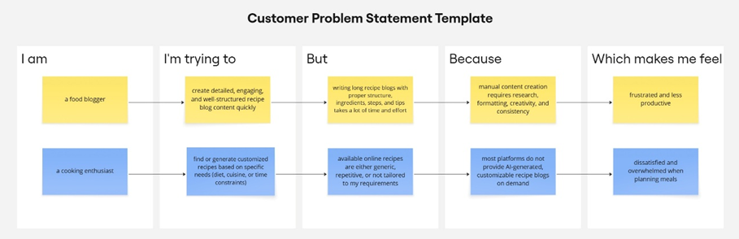

Problem  Statement  (PS) | I am | I’m trying to | But | Because | Which makes me feel
PS-1 | A food blogger | Create detailed, and high-quality recipe blog content in less time | Writing long and recipe blogs manually is time-consuming | It requires research, creativity, formatting, and consistency | Frustrated and less productive
PS-2 | A cooking enthusiast | Generate customized recipes | Existing recipes available online are generic and not customizable | Most platforms do not offer AI-driven recipe blog generation | Dissatisfied and overwhelmed while planning meals

2.2. Project Proposal (Proposed Solution)
Project Overview
Objective | The main objective of this project is to develop an AI-powered web application that generates customized and high-quality recipe blogs based on user inputs.
Scope | The scope of the project includes building a Streamlit-based web interface where users can enter a recipe topic and desired word count. The system generates a complete recipe blog using an AI model and displays it to the user.
Problem Statement
Description | Many food bloggers and users find it difficult to create detailed and well-structured recipe blogs within a short time. Manual content creation requires creativity, research, and proper formatting, making it time-consuming.
Impact | Solving this problem helps users save time and effort while creating customized recipe blogs
Proposed Solution
Approach | The proposed solution uses a Streamlit web application integrated with the Gemini Flash Lite model. Users provide a recipe topic and word count through the UI. The AI model processes the input and generates a complete recipe blog.
Key Features | - User-friendly Streamlit interface  - Custom recipe blog generation based on topic and word count  - AI-powered content generation using Gemini Flash Lite  - Programmer joke display for better user experience

Resource Requirements
Resource Type | Description | Specification/Allocation
Hardware
Computing Resources | CPU for application execution | Standard system CPU
Memory | RAM required to run application | 8 GB
Storage | Disk space for application files | 50 GB SSD
Software
Frameworks | Python web framework | Streamlit
Libraries | AI and utility libraries | google-generativeai
Development Environment | IDE and version control | VS Code, Git
Data
Data | User input text | Recipe topic and word count entered by user

2.3. Initial Project Planning
Product Backlog, Sprint Schedule, and Estimation
The following table represents the product backlog and sprint-wise planning for the Flavour Fusion project.
Sprint | Functional Requirement (Epic) | User Story Number | User Story / Task | Story Points | Priority | Team Members | Sprint Start Date | Sprint End Date
Sprint 1 | User Interface Setup | USN-1 | As a user, I can access a Streamlit-based interface to enter a recipe topic and word count. | 2 | High | All Team Members | 28 January 2026 | 31 January 2026
Sprint 1 | Input Validation | USN-2 | As a user, I want the application to validate my inputs before generating the recipe. | 1 | High | All Team Members | 28 January 2026 | 31 January 2026
Sprint 2 | AI Model Integration | USN-3 | As a user, I want the system to generate a recipe blog using the Gemini Flash Lite model. | 3 | High | All Team Members | 02 February 2026 | 09 February 2026
Sprint 2 | Joke Generation | USN-4 | As a user, I want to see a programming joke while the recipe is being generated. | 1 | Medium | All Team Members | 02 February 2026 | 09 February 2026
Sprint 3 | Output Display | USN-5 | As a user, I want to view the generated recipe blog clearly on the screen. | 2 | High | All Team Members | 12 February 2026 | 18 February 2026
Sprint 3 | Deployment | USN-6 | As a user, I want the application to be deployed and accessible through the internet. | 2 | Medium | All Team Members | 12 February 2026 | 18 February 2026

3. Data Collection and Preprocessing Phase
3.1. Data Collection plan and Raw Data Sources Identified
3.1.1. Data Collection Plan
Section | Description
Project Overview | Flavour Fusion is an AI-driven recipe blogging application that generates customized recipe blogs based on user input. The project dynamically processes user-provided text input to generate content.
Data Collection Plan | The data for this project is collected directly from users at runtime through a Streamlit-based web interface. Users provide:  - Recipe topic  - Desired word count
Raw Data Sources Identified | Since this project uses real-time user input and a pre-trained AI model, no external datasets (CSV, images, or files) are collected or stored.

3.1.2. Raw Data Sources Template
Source Name | Description | Location/ URL | Format | Size | Access Permissions
User Input Data | Text entered by users (recipe topic & word count) | Streamlit Web Interface | Text | Small | Public  (user-provided)
AI Model Output | Generated recipe blog content | Gemini Flash Lite API | Text | Variable | Restricted  (API-based)
3.2. Data Quality Report
Data Quality Report
The Data Quality Report summarizes potential data quality issues related to user-provided input in the Flavour Fusion application. Since the project does not rely on an external dataset, data quality focuses on ensuring valid, clean, and meaningful text input before processing by the AI model.
Data Source | Data Quality Issue | Severity | Resolution Plan
User Input (Text) | Empty or missing recipe topic | High | Input validation is applied to ensure the topic field is not empty before submission.
User Input (Text) | Invalid or very low word count | Moderate | Word count is validated to ensure it falls within an acceptable range.
User Input (Text) | Special characters or extra spaces | Low | Input text is cleaned by trimming unnecessary spaces before processing.
User Input (Text) | Ambiguous or unclear prompts | Low | Clear prompt formatting is applied before sending input to the AI model.

3.3. Data Preprocessing
In the Flavour Fusion project, data preprocessing focuses on user-provided textual input rather than images. Since the application uses a pre-trained generative AI model, no traditional dataset collection or image preprocessing is required.
Section | Description
Data Overview | The data used in this project consists of user-entered text inputs such as recipe topic and desired word count. No external dataset is used.
Text Cleaning | User input is cleaned by removing unnecessary spaces and validating empty or invalid entries.
Input Validation | Ensures the recipe topic is not empty and the word count is within an acceptable range.
Token Handling | The input text is passed to the Gemini Flash Lite model, which internally handles tokenization and text processing.
Prompt Formatting | The user input is formatted into a structured prompt before being sent to the AI model for recipe generation.
Error Handling | Handles invalid inputs or API-related issues gracefully by displaying appropriate error messages.
Data Preprocessing Areas
Loading Data | User inputs are collected directly through Streamlit text input fields.
Input Validation | Code ensures valid recipe topic and word count before processing.
Prompt Creation | Code formats the validated input into a prompt for the Gemini Flash Lite model.
Model Invocation | The formatted prompt is sent to the AI model for recipe blog generation.
Output Handling | The generated recipe text is received and displayed on the Streamlit interface.

4. Model Development Phase
4.1. Model Selection Report
In this project, the focus is on selecting a pre-trained generative language model suitable for real-time recipe blog generation. Unlike traditional deep learning projects that require training CNNs or RNNs, this application leverages an existing large language model (LLM) to generate high-quality text content. The model is selected based on performance, response time, ease of integration, and suitability for text-based content generation.
Model | Description
Gemini Flash Lite (models/gemini-flash-lite-latest) | A lightweight pre-trained generative language model designed for fast and efficient text generation. It supports real-time content creation with good coherence, relevance, and low latency, making it ideal for recipe blog generation.

4.2. Initial Model Training Code, Model Validation and Evaluation Report
In this project, no custom model training is performed. Instead, a pre-trained generative AI model is integrated and used for recipe blog generation. The focus of this phase is on model selection, configuration, prompt design, and output evaluation, rather than training from scratch.
Initial Model Training Code:
Model Selection and Initialization
The Gemini Flash Lite (models/gemini-flash-lite-latest) model is selected due to its lightweight architecture, faster response time, and suitability for real-time text generation tasks.
The model is initialized using the Google Generative AI API. Configuration parameters such as temperature, top-p, top-k, and maximum output tokens are defined to control creativity, response quality, and output length.
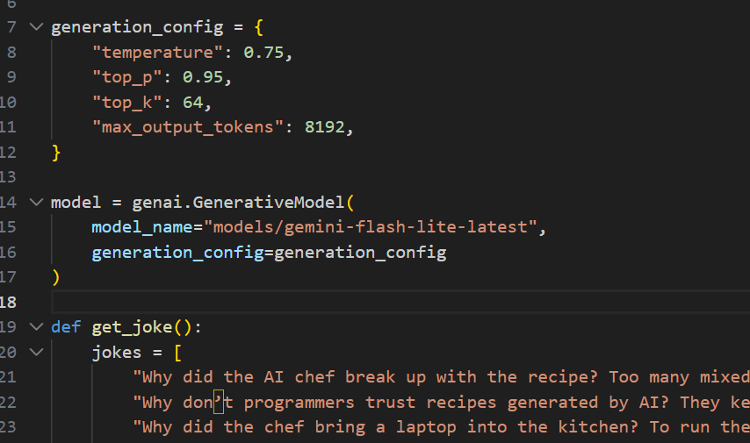
Model Validation and Evaluation Report:
Model | Summary | Training and Validation Performance Metrics
Gemini Flash Lite | Pre-trained generative language model optimized for fast text generation | Relevance of generated content, adherence to word count, coherence, clarity, and response time

5. Model Optimization and Tuning Phase
5.1. Tuning Documentation
The Model Optimization and Tuning Phase focuses on improving the performance and quality of the generated recipe blogs by configuring and fine-tuning model generation parameters rather than training a neural network from scratch. Since the project uses a pre-trained generative AI model, optimization is achieved through prompt design and parameter tuning.

Hyperparameter Tuning Documentation:
Model | Tuned Hyperparameters
Gemini Flash Lite | Temperature: Controls creativity of output (set to a moderate value for balanced creativity).  Top-p: Limits token selection to the most probable tokens for coherent responses.  Top-k: Restricts token sampling to reduce irrelevant content.  Max Output Tokens: Ensures generated recipe blogs match the desired word count.  Response Format: Set to plain text for easy display in the UI.

5.2. Final Model Selection Justification
Final Model | Reasoning
Gemini Flash Lite (models/gemini-flash-lite-latest) | Selected due to its fast response time, efficient resource usage, high-quality text generation, and seamless integration with Streamlit for real-time recipe blog generation.

6. RESULTS
6.1. Output Screenshots
The complete execution of Flavour Fusion: AI-Driven Recipe Blogging application is represented step by step in the following screenshots.
Step 1: To run the Streamlit Application we have to use the command streamlit run app.py in the terminal in path where the app.py file is located.
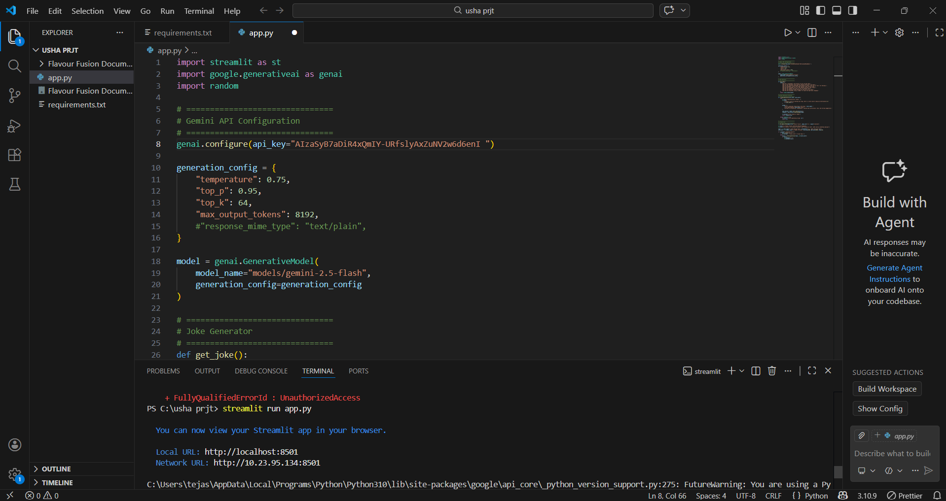
Step 2: After running the command in terminal, the code will get executed and the webpage will open directly. Another way to open webpage is that a localhost link will get generated in the terminal, we can access the webpage using that link.
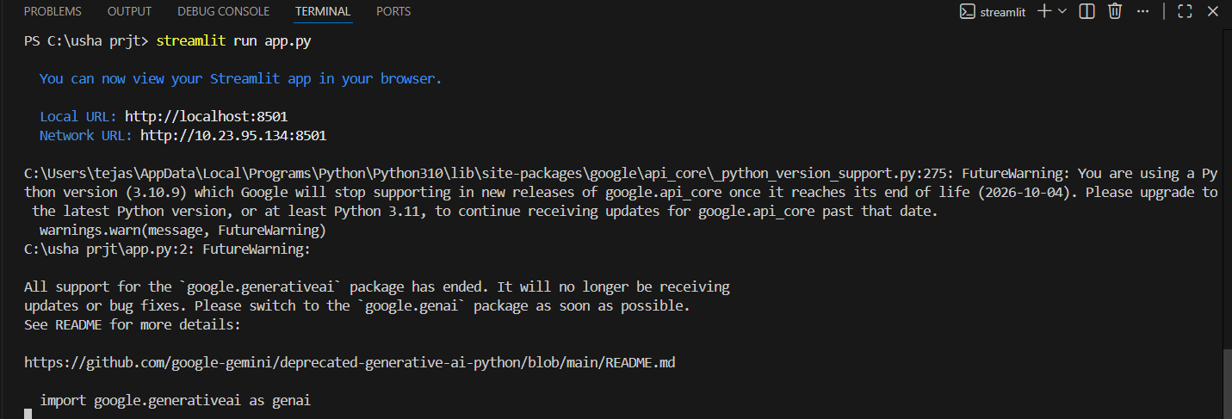
Step 3: The Streamlit webpage opens as shown in the figure given below. This is an automated webpage. No secondary HTML codes required to build this webpage. Python code itself consists the webpage building code.
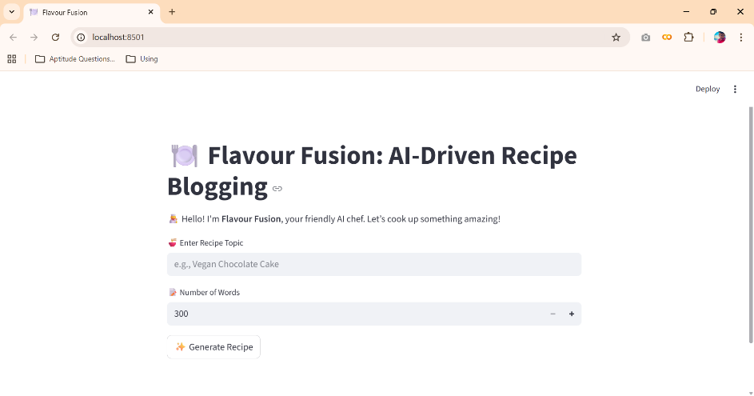
Step 3: The user has to give inputs in the website such as a Recipe Name and Number of Words. The Number of words means with how many words the recipe should be generated. After entering the required details, the user should click on Generate Recipe button to generate the recipe. Here I chose the Chocolate Cake Recipe with 400 words count.
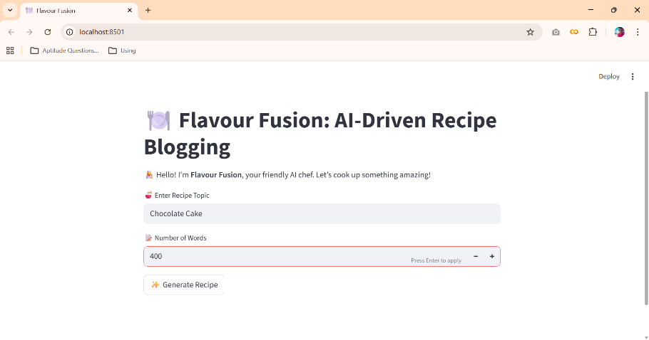
Step 4: After clicking the Generate Recipe button, in fraction of seconds a simple joke will be generated as shown in the below figure to engage the users if recipe generation get delayed. The Food Recipe will be generated based on the user inputs as shown in the following four images.
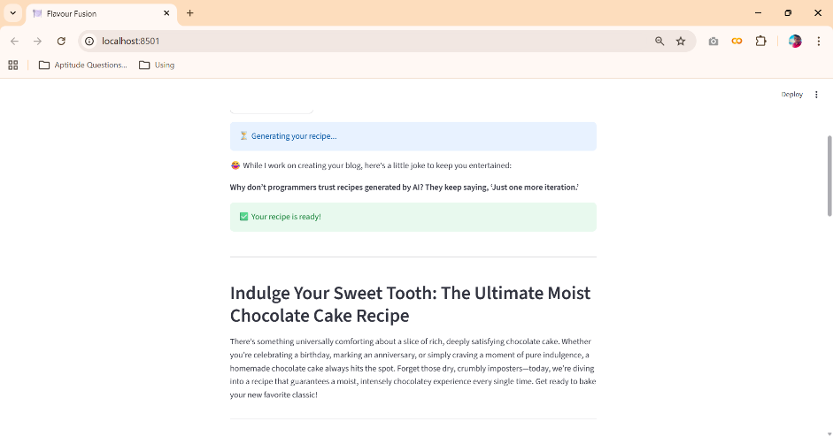
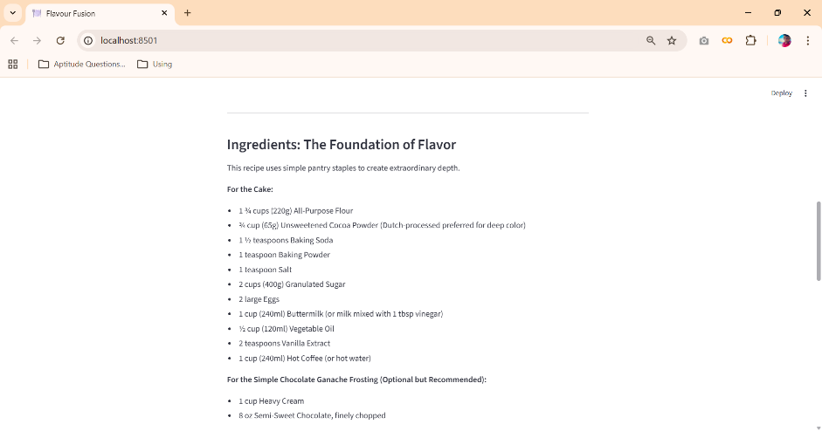
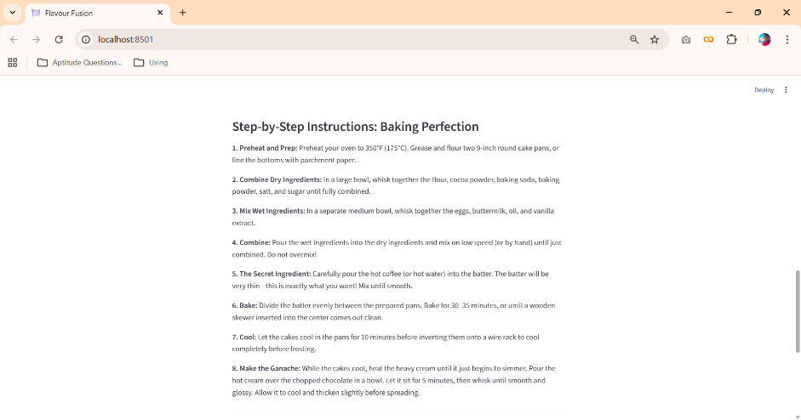
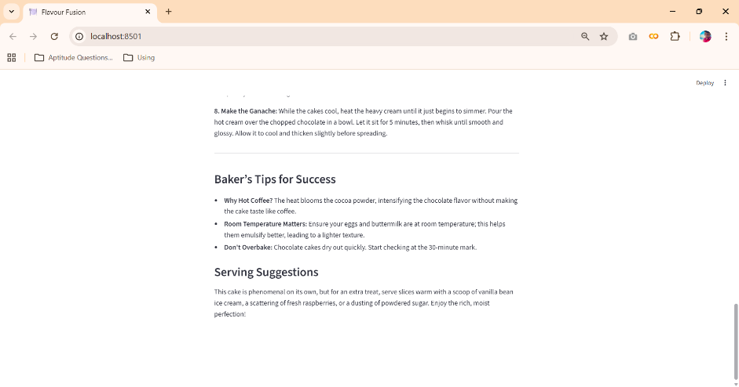

7. ADVANTAGES AND DISADVANTAGES
Advantages
- Saves time by automatically generating detailed recipe blogs
- Reduces manual effort for food bloggers and users
- Generates customized content based on user input
- User-friendly interface built using Streamlit
- Fast and efficient content generation using a pre-trained AI model
- No requirement for dataset collection or model training
Disadvantages
- Requires an active internet connection to access the AI model
- Depends on third-party AI APIs for content generation
- Limited to text-based recipe content only
- Output quality depends on the clarity of user input

8. CONCLUSION
The Flavour Fusion: AI-Driven Recipe Blogging project successfully demonstrates how generative AI can be used to automate recipe blog creation. The application allows users to generate customized and well-structured recipe content by providing a topic and word count, reducing the time and effort required for manual writing. By integrating a pre-trained AI model with a user-friendly Streamlit interface, the project delivers fast, efficient, and high-quality results, making it a useful tool for food bloggers and cooking enthusiasts.

9. FUTURE SCOPE
The Flavour Fusion project can be enhanced further by adding support for multiple languages to reach a wider audience. Future improvements may include generating recipe images along with text, adding user accounts to save favorite recipes, and providing personalized recipe recommendations. The application can also be extended to support voice-based input and mobile platform deployment, making it more accessible and user-friendly.

10. APPENDIX
10.1. Source Code
The source code for the Flavour Fusion: AI-Driven Recipe Blogging project includes the implementation of the Streamlit user interface, integration of the Gemini Flash Lite model using the Google Generative AI API, recipe blog generation logic, and the programmer joke feature. The code is written in Python and follows a modular and readable structure.
10.2. Github & Project Demo Link

